

POWDERPLOT

Powder diffraction plotting and handling program
Written and collected by
Kenny Ståhl
Department of Chemistry
Technical University of Denmark
2800 Lyngby, Denmark
kenny@kemi.dtu.dk

With PowderPlot you can open and plot powder diffraction patterns from different standard formats, save to different standard formats, modify your pattern, plot and fit multiple patterns, perform peak searches, fit single peaks or full patterns and index patterns.
Start the program by double-clicking the program icon or by drag-and-drop a powder pattern file in an appropriate format on the program icon.
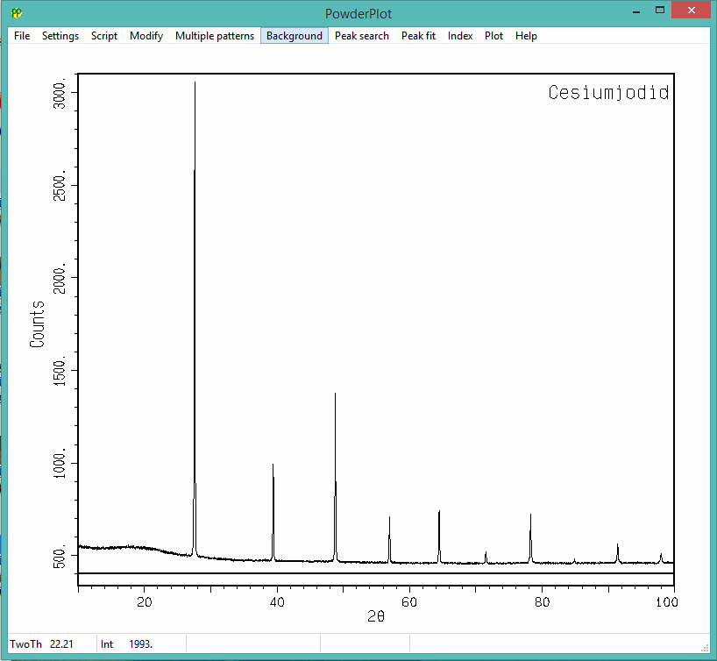

The position of the cursor when inside the pattern box can be seen in the lower left corner. Pressing and dragging the left mouse button will zoom in the pattern. Using the arrow keys you can move the selected section left or right, or increase or decrease it by using up and down arrows respectively. Press F1 to restore the full pattern.

Most features are thought to be self-explanatory, but a short graphical overview is given in the following.

File Menu
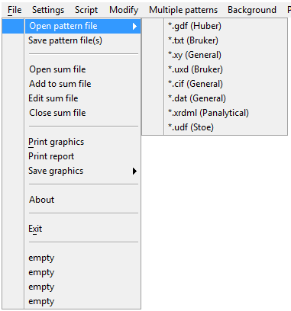

Pattern of different standard formats can be opened. If you need a special format, please get in touch, it can probably be arranged.

“Print graphics” will print the graphics window and some additional information.
“Print report” will print a special report sheet with the original pattern.

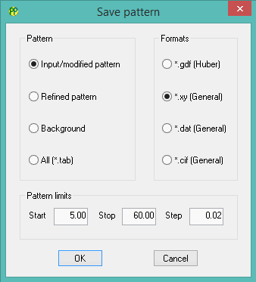
Patterns can be saved in some general format. To save all generated patterns check “All” and they are saved as a big table that can be imported by most spread-sheets and graphics programs.

If the step size is increased, points will be averaged. When the new step size is not a multiple of the original, a spline function will be calculated and sampled with the intended step size.

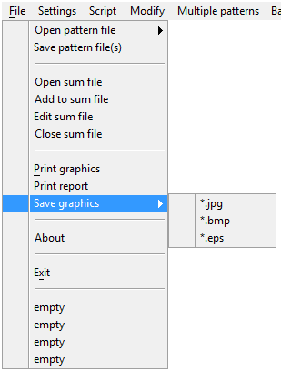
Different patterns can be added to one file. “Open sum file” and give a file name. Then for each opened file press “Add to sum file”. The resulting file can be viewed with “Edit sum file”. When done, press “Close sum file”

The graphics can be saved directly in jpg, bmp or eps formats.

Previously opened files will be listed at the end, and these can be opened directly by clicking their names.

Settings Menu
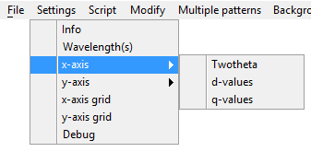

The x-axis can be given in 2θ, d- values or q-values.

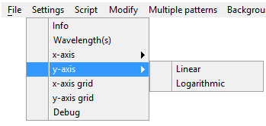

The y-axis can be given as linear or logarithmic.

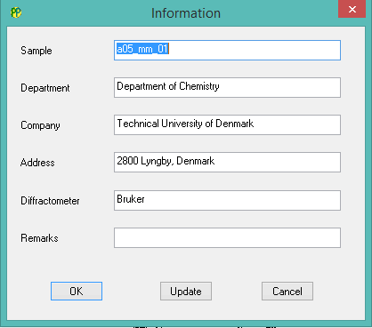
Information that are printed on the report sheet (“Print report”) can be edited in this dialog. Pressing “Update” will add it to the PowderPlot.ini-file stored in the same directory as the program. This file can be edited directly as well.

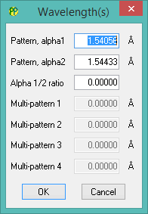

The wavelength information can be changed here. With powder pattern formats not containing wavelength information default will be CuKα-radiation.

The “Debug” option can be used to generate dialog boxes to indicate how far you are when you experience a program crash. May require a lot of OK-clicking.

Script Menu

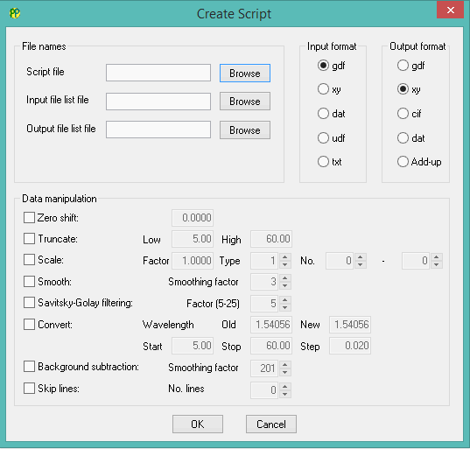
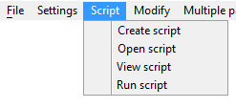
The script option allow you to handle large amounts of for instance in situ data. When creating a script you give a name for the script instruction file, a file containing a list of input files (has to be created separately) and a file containing the names of the output files, or a table file to collect all data. With “Open script” you can view and edit the script in the dialog box. With “View script” you can view the script file, and with “Run script” the script is executed.

Checking the different options will open up for editing.

Modify Menu
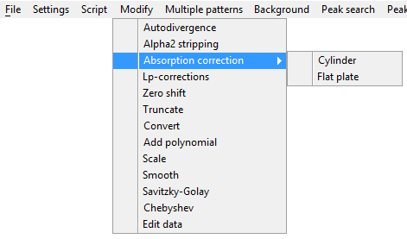

“Autodivergence” will correct for auto-divergence slit.
Edit data will show the original data in a text editor.

A variety of dialog boxes will appear:

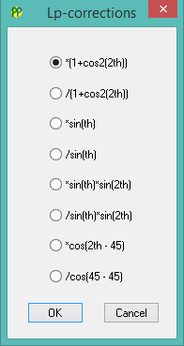
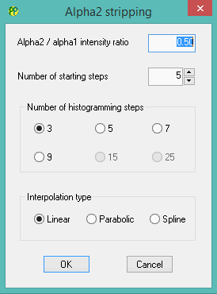

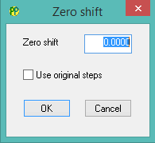
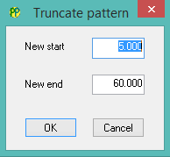

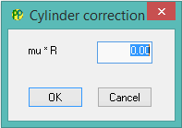
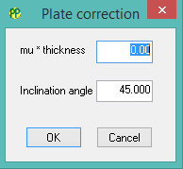
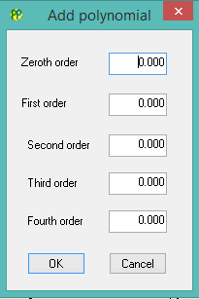
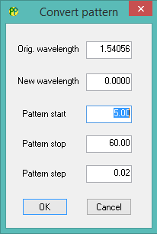

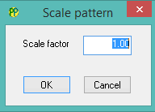
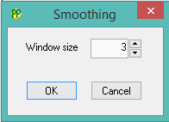

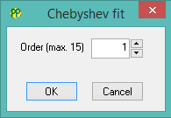
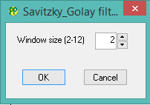

Multiple Patterns Menu

The multiple patterns menu allow you to open four more patterns.
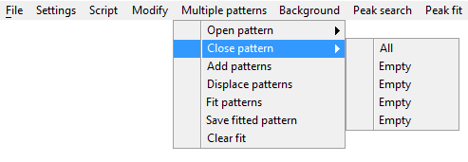
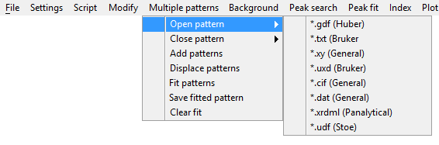
The patterns can be closed individually or all at once.

All displayed patterns can be added into one pattern with “Add patterns”.
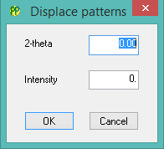

The patterns can be displaced in 2θ and/or intensity for illustrative purposes.

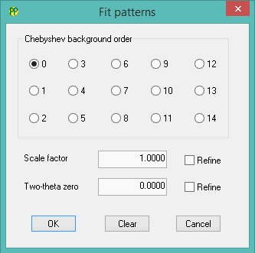

Two patterns can be scaled and background fitted to each other. The 2θ- zero shift should be entered manually.

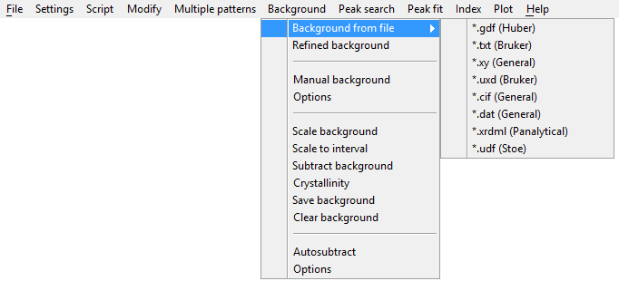
Background Menu

An experimental background curve can be entered in standard format as can a refined background.

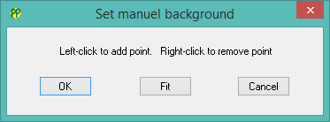
The background level can be set manually. Left-click when the cursor is in a desired position. Placing the cursor on top of a previously marked point and right- click to remove it. Press “Fit” to generate a background curve.

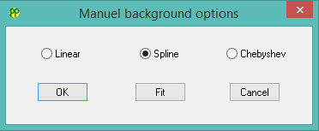
The curve generation can be controlled by the “Options” dialog.

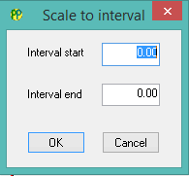
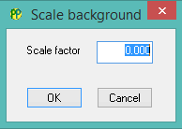

An entered or fitted background can be scaled with a simple overall scale factor, or fitted to a given interval.
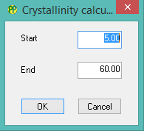

Based on a background the crystallinity can be calculated in a given interval.

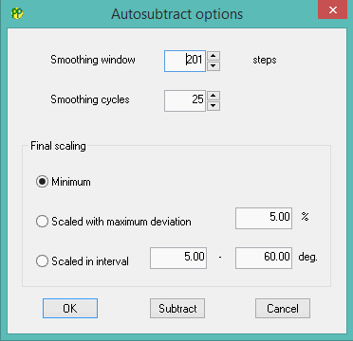

The background may be determined and subtracted automatically using a robust smoothing algorithm. A reasonable smoothing window is 1/step size.

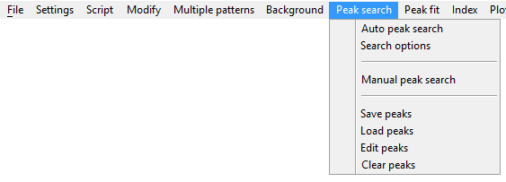
Peak Search Menu

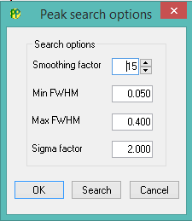

Peak positions can be found automatically, however, this routine does not work optimally.

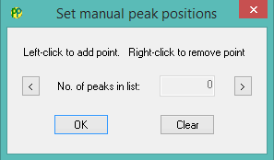
Instead, it is recommended to set peak positions manually. Left-click when the cursor is in an appropriate position. Position the cursor on top of a previous peak position and right-click to remove. It is suggested to zoom in on a limited 2θ-region and then move it with the left and right arrow keys in the dialog box.

The peaks can be saved in a .pks-file and edited. Previous peak lists can be loaded and worked on.

Peak Fit Menu

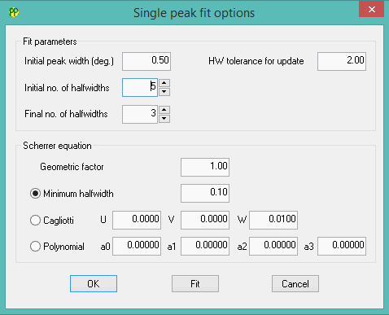
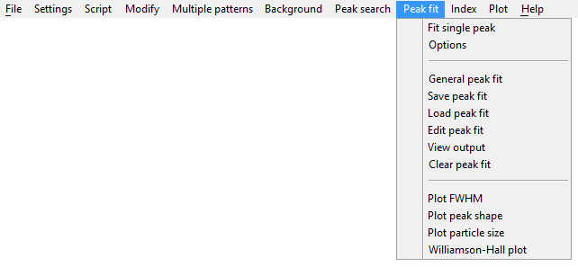
Zooming in on peak and pressing “Fit single peak” will fit a split pseudo-Voigt function to the peak. The crystallite size will be calculated using the minimum half-width parameters in the “Options” dialog box.
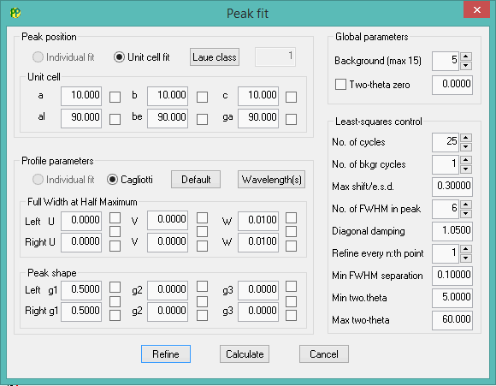
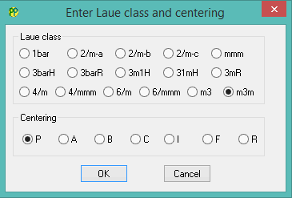
A general peak fit can be performed based on a trial unit cell. Parameters are chosen using the check boxes. The peak function is a split pseudo-Voigt function. By checking the middle checkbox the U, V, W, γ1, γ2 and γ3 parameters can be refined combined for the left and right hand side, respectively.

Laue class and centering can be chosen when pressing the “Laue class” button.

The fit can be saved in a .fit-file and reloaded. FWHM, peak shape, particle size and a Williamson-Hall plot can be calculated from the saved fit.
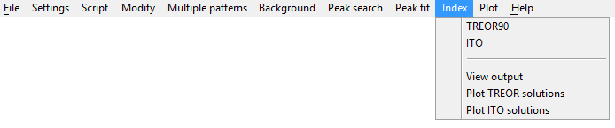
Index Menu

Based on the peak positions in the .pks-file an indexing can be performed using TREOR90 (P.-E. Werner et al. J. Appl. Crystallogr. 18 (1986) 367. ) or ITO (J.W. Visser, J. Appl. Crystallogr. 2 (1969) 89.)
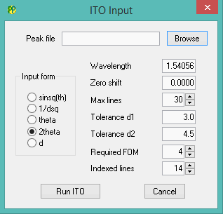
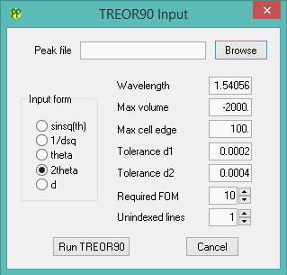
Both routines require a .pks-file. The ITO routine requires 20 reflections to work.

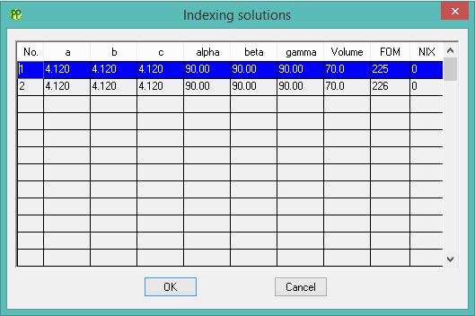
The suggested cells from the indexing routines can be used to calculate peak positions and shown in the diffraction pattern. The latest chosen cell will be preloaded into the general peak fit routine.

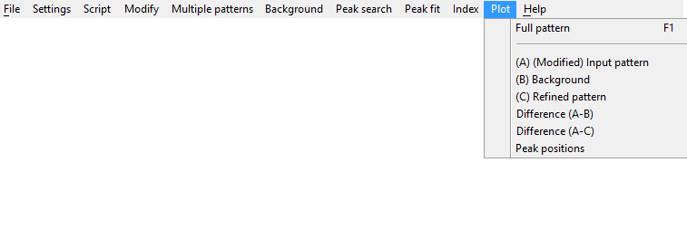
Plot Menu
There are different options for pattern plotting. The availability is of course dependent on previous actions.

